Media Release

FOR IMMEDIATE RELEASE

Dive into the Extraordinary Life of Conservation Icon Valerie Taylor
at Tomaree Headland, NSW – 18 March until 17 April 2026.

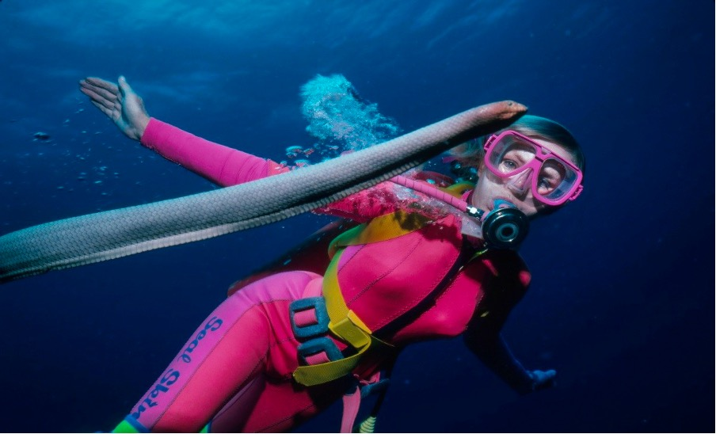

The extraordinary story of Valerie Taylor AM —globally celebrated underwater storyteller, shark researcher, and conservationist—is coming to Tomaree Headland, near Shoal Bay, in the captivating new exhibition, Valerie Taylor – An Underwater Life (Regional Tour).

The exhibition will be on display from 18 March until 17 April 2026. Opening hours are 9 a.m. to 3 p.m.

This beautifully designed exhibition tells the story of Valerie Taylor's remarkable life and career. Through a stunning collection of images, text, and never seen on tour 3D scans of objects, the exhibition showcases the pioneering work of Valerie and her husband Ron. It highlights their significant contributions to marine conservation, their innovations in diving, and their groundbreaking underwater filmmaking that has inspired generations.

More than just a retrospective, Valerie Taylor – An Underwater Life serves as a compelling call to action. It aims to inspire a new generation of ocean advocates and changemakers to protect marine biodiversity. The exhibition delves into Valerie's tireless advocacy, her achievements as a marine conservation pioneer, and provides important insights into shark safety, challenging common misconceptions.

“We are incredibly proud to host this important exhibition at the Main Hall, Tomaree Lodge” said Doug Cross, Chairman of the Tomaree Museum Association (TMA). “Valerie Taylor’s legacy is a powerful reminder of our connection to the ocean, and we hope her story will inspire our community to become advocates for marine protection.”

“The exhibition includes displays from the TMA’s Sustained by the Sea project as well as exciting models and artifacts by Matt and Julie Johnstone from Atlantis.
“We are extremely grateful to the NSW Government Department of Communities and Justice for allowing the TMA the temporary use of the Main Hall at the Tomaree Headland Precinct for this travelling exhibition and also acknowledge the support of Port Stephens Council.

Valerie Taylor – An Underwater Life (Regional Tour) is presented by the Australian National Maritime Museum and has been assisted by the Australian Government's Visions of Australia program. This exhibition was developed by the Australian National Maritime Museum and debuted in 2023. It will tour venues across New South Wales and Western Australia from 2026 to 2027.

Entry to the exhibition at Main Hall, Tomaree Lodge Precinct is free. For more information, please visit tomareemuseum.org.au.

For further information, please contact:
Doug Cross
Chairman
Tomaree Museum Association
e: acdc01@iinet.net.au
m: 0432 058 000

Kevin McGuiness
Public Relations Manager
Tomaree Museum Association
e: kevinmcguiness1@gmail.com
m: 0422 643 159



PH: 0422 643 159
kevinmcguinness1@gmail.com

