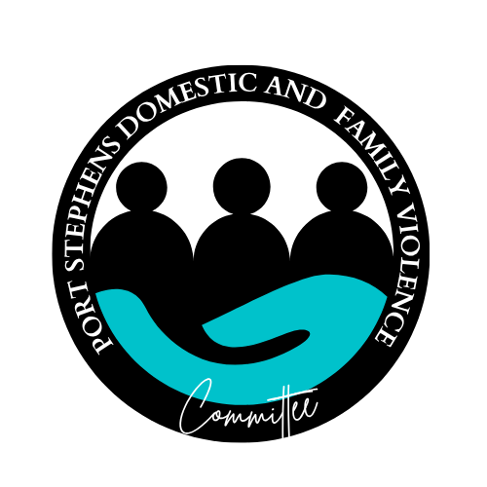
Port Stephens Domestic Violence Committee Meeting
Minutes

Date: Monday 13th October 1:30pm -3pm
Location: 5 Phillip Street Raymond Terrace
Chair: Bec

Minute taker Kadina

Attendees: Bec McAliney, Kadina Barker, Sarah Quinlan, Karen Pattern, Adrian Smith and Lisa Ronneberg (PSFaNS), Tracey McKenzie (Zahra Foundation)
Via TEAMS: Angela Endersby (Community Corrections), Alison Jordan (NSW Police), Breanna Landwehr (Community for children/The Smith Family), Giacomo Arnott, Elissa Creedy and Danelle (Warlga Ngurra), Roger Yeo (White Ribbon)

Apologies: Charna Lieben (PSFaNS)

Agenda
Introductions

Existing business  Term of reference  - The revised TOR was provided to the committee and was all agreed by members present.  Hunter DVF forum- Has anyone secured a prize?  - Forum to be held December 3rd 2025 in Newcastle.  - Tickets selling fast  - Each Hunter DFV committee has been asked to donate a prize for a raffle.  DFV committee website  - Have until December to finalise funding  - PSFaNS IT service to develop website.  Discussion re:  - Mock website designed by PSFaNS admin Jo – overall style/colour/layout approved by committee  - Website calendar: how this will be updated by committee members and the purpose due to other services doing community calendars.  - Resources on the website: suggestion to include information for people who use violence and include link to the Hunter Men’s Project | Action Items  - TOR will be revised again in 2027.  - Committee members continue to follow up with contacts for potential donation.  - Bec to follow up with local businesses to see if they have any donations  - Committee to further discuss website content at 16 Days planning meeting - Bec to confirm estimated timeframe for website completion prior to next meeting
New Business | Action Items
16 Days of Activism – Grant approved.  - Bec and Charna was supported by Lisa to apply for the grant, which was recently approved  - The following was approved  - Small Steps for Hannah workshop and DFV service expo (27th of Nov) including catering, hall hire, the presenter and acknowledgement of country  - DFV Committee printed bags/posters with Primary Prevention messages  - Financial literacy workshops  - DFV discreet resource card – draft design by Lisa | - DFV Committee will meet again on the 20th of October at 1:30pm via TEAMs to discuss 16 Days of Activism events  - Speak to Bec or Charna if you missed the meeting and would like to be involved with the planning of 16 days of Activism.
Service Updates  Presentation (Tracey) : Zahra Foundation Pathways to Empowerment Program  - Zahra Foundation Pathways started 10 years ago to support women and non-binary people after experiencing violence, with the next steps focusing on long-term planning, such as study and work. The program focuses on what comes after the crisis is over, with safety already established. It is client lead on what they are needing and sowing the seeds of hope for the future. The experience of abuse can be from years ago or recent to be eligible as long as there is no ongoing crisis.  - Tracey provided flyers for upcoming programs.  - Please contact Tracey if you have further questions. 0422 233640  Police – Alison  Discussion around the recent statistics for Port Stephens for September  - 144 ADVO applications, PS 3rd in the state, 1st in the region  - 55 breaches with 38 with legal action, 48 repeat victims  - Discussion re: patterns and trends of the statistics.  Lisa  Hunter DV Forum  - Tickets are live and active for sale.  - Excited for our key note speakers Elsie Randall, Jess Hill (Industry Professor UTS), Carly Clarke (DV NSW), Cameron McDonald (Our Watch), Gulnara Abbasova (SSI’s Head of DFSV Prevention & Response)  - Hunter Men’s Project primary prevention early intervention event also occurring-  Tickets will be open Tue 14th Oct. This event is open to all workers  TFA  - The funding has now finished that was used for the playbook and workshops that was run in the Hunter LGA.  - Further funding has been applied to digitise the TFA playbook to make it more user friendly for workers to use and for e-learning to increase knowledge of workers  Primary Health – PSFaNS  - Federal funding has been now approved to support for mild brain injury. This will start next year.  - The next stage will be running focus groups, talking with professionals with expert knowledge on brain injuries and a pathway to access support for community members.  - This will support a new model of care for workers supporting clients with mild brain injuries.  Roger  White ribbon breakfast  - Keep in your calendars for the Hunter White Ribbon morning tea as the raising will go towards the Hunter DFV consortium  Breanna  Community for Children  - Running parenting programs such as parenting after violence  - Working in the Port Stephens area such as Karuah, Raymond Terrace and Tea gardens  - Running other great programs such as food education | - Send Bec or Charna an email if you would like to be added to Lisa’s Hunter/Newcastle sector Newsletter

Next meeting
DATE Monday 8th December 1:30pm – 3pm
TEAMS option will be available

